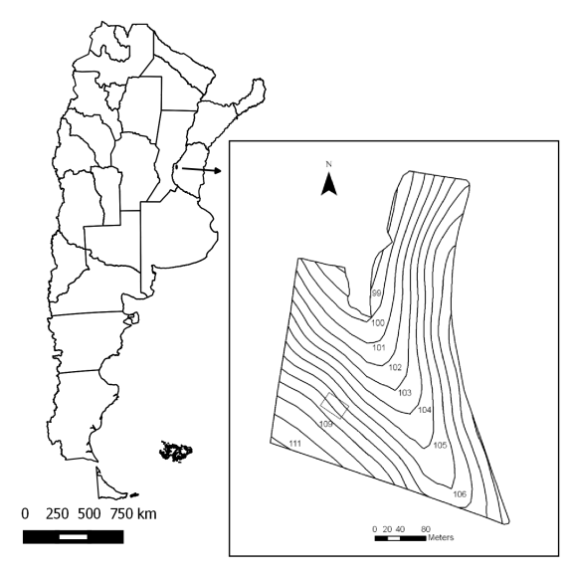

Figure 1. Location of the study area (in gray) within the agricultural plot (contour map).

Table 1. Soil sampling dates, crop type and crop development stage during the study period.

Date | Period |  | Crop | Crop Stage
01/07/2010 | F1 |  | wheat | Emergence
13/10/2010 | F2 |  | wheat | Flowering
09/12/2010 | F3 |  | fallow | Postharvest
09/03/2011 | F4 |  | soybean | Small beans
04/08/2011 | F5 |  | fallow | Postharvest
13/12/2011 | F6 |  | corn | Vegetative (V6)

Table 2. Values of soil water content, rain fallen in the 5, 10 and 15 days prior to each sampling date and mean daily temperatures of the 5, 10, 15 and 30 days prior to each sampling date.

Date | Period | SWC | CV | R5 | R10 | R15 | T5 | T10 | T15 | T30
01/07/2010 | F1 | (g g⁻¹)  0.27 | (%)  6 | (mm)  2.0 | (mm)  2.0 | (mm)  11.0 | (ºC)  10.0 | (ºC)  11.1 | (ºC)  11.4 | (ºC)  12.2
13/10/2010 | F2 | 0.22 | 5 | 0.0 | 4.4 | 12.5 | 17.3 | 17.4 | 15.7 | 16.1
09/12/2010 | F3 | 0.10 | 9 | 0.0 | 6.0 | 15.2 | 24.3 | 23.6 | 23.6 | 21.8
09/03/2011 | F4 | 0.11 | 5 | 0.0 | 0.0 | 22.0 | 24.9 | 24.3 | 23.8 | 24.0
04/08/2011 | F5 | 0.36 | 7 | 21.7 | 32.4 | 10.7 | 7.1 | 10.7 | 10.6 | 12.0
13/12/2011 | F6 | 0.11 | 9 | 0.0 | 0.0 | 10.1 | 25.0 | 24.7 | 23.7 | 23.4
SWC: soil water content prior to rainfall simulations. R5, R10, R15: rain fallen during the 5, 10 and 15 days prior to each sampling date, respectively. T5, T10, T15, T30: average daily mean temperature of the 5, 10, 15 and 30 days prior to each sampling date, respectively. CV: coefficient of variation.

Table 3. Correlation coefficients between soil water content and change in mean weighted diameter of soil aggregates with rain fallen during the 5, 10 and 15 days prior to each sampling date and mean daily temperatures of the 5, 10, 15 and 30 days prior to each sampling date.

 | SWC | CMWD
SWC | 1.00** | 0.77ns
R5 | 0.80* | 0.62ns
R10 | 0.76ns | 0.58ns
R15 | -0.52ns | -0.73ns
T5 | -0.98** | -0.84*
T10 | -0.96** | -0.84*
T15 | -0.97** | -0.80ns
T30 | -0.95** | -0.83*
*(P < 0.05), **(P < 0.01), ns: non-significant differences. SWC: soil water content prior to rainfall simulations. CMWD: change in the mean weighted diameter of soil aggregates. R5, R10; R15: rain fallen during the 5, 10 and 15 days prior to each sampling date, respectively. T5, T10, T15, T30: average daily mean temperature of the 5, 10, 15 and 30 days prior to each sampling date, respectively.

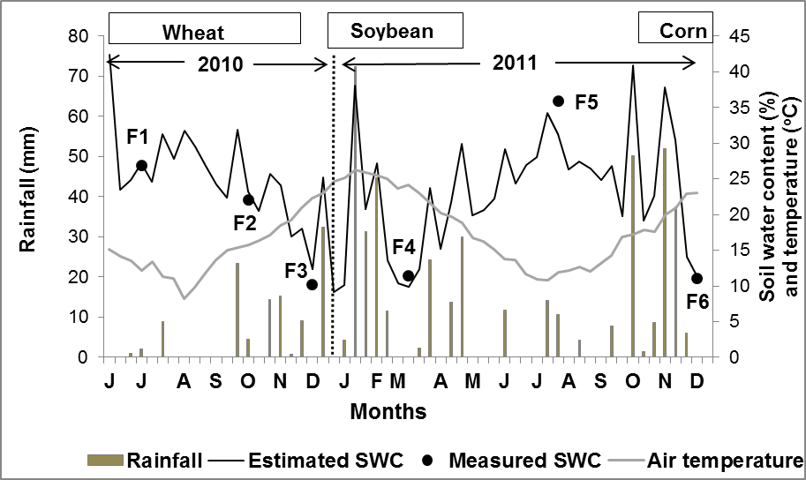

Figure 2. Measured and estimated soil water content, rainfall, mean air temperature and cropping season of the different crops.

Table 4. Soil physical properties determined at different times of the rotation cycle.

Date | Period | >50 µm | CV | 10-50 µm | CV | BD | CV | CMWD | CV
 |  | cm³ cm⁻³ | % | cm³ cm⁻³ | % | g cm⁻³ | % | mm | %
01/07/2010 | F1 | 0.15 a | 40 | 0.15 ab | 17 | 1.33 a | 12 | 0.65 a | 32
13/10/2010 | F2 | 0.17 a | 64 | 0.16 a | 35 | 1.29 a | 17 | 0.53 a | 12
09/12/2010 | F3 | 0.20 a | 33 | 0.11 bc | 18 | 1.17 a | 12 | 0.56 a | 15
09/03/2011 | F4 | 0.18 a | 21 | 0.11 c | 15 | 1.38 a | 5 | 0.47 a | 23
04/08/2011 | F5 | 0.13 a | 34 | 0.13 abc | 19 | 1.35 a | 11 | 0.64 a | 13
13/12/2011 | F6 | 0.16 a | 41 | 0.13 abc | 36 | 1.34 a | 16 | 0.54 a | 18
Different lowercase letters within a column indicate significant differences (P < 0.05). >50 µm: volume occupied by pores with effective diameter larger than 50 µm. 10-50 µm: volume occupied by pores with effective diameter between 10 and 50 µm. BD: bulk density. CMWD: change in the mean weighted diameter of soil aggregates. CV: coefficient of variation.

Table 5. Runoff coefficient (RC) and equilibrium infiltration rate (EIR) values in covered and bare soil for the different periods studied.

Date | Period | Covered soil |  |  |  | Bare soil
Date |  | RC CV |  | EIR CV |  | RC CV |  | EIR CV
 |  | % | % | mm h⁻¹ | % | % | % | mm h⁻¹ | %
01/07/2010 | F1 | 46.0 ab | 53 | 18.9 bc | 92 | 56.0 a | 16 | 8.6 e | 64
13/10/2010 | F2 | 10.7 bc | 173 | 46.2 ab | 47 | 26.7 b | 67 | 25.6 cd | 46
09/12/2010 | F3 | 0.0 c | 0 | 60.0 a | 0 | 0.0 c | 0 | 60.0 a | 9
09/03/2011 | F4 | 7.0 c | 38 | 52.8 a | 3 | 13.5 bc | 4 | 43.7 b | 14
04/08/2011 | F5 | 70.0 a | 11 | 7.5 c | 75 | 62.8 a | 7 | 11.1 de | 40
13/12/2011 | F6 | 2.6 c | 105 | 53.3 a | 7 | 15.0 bc | 49 | 35.7 bc | 13
Different lowercase letters within a column indicate significant differences (P < 0.05). CV: coefficient of variation

Table 6. Correlation coefficients between runoff coefficient (RC) and equilibrium infiltration rate (EIR) with other weather and soil variables.

 | Covered soil |  | Bare soil
 | RC | EIR | RC | EIR
SWC | 0.95** | -0.96** | 0.96** | -0.88*
R5 | 0.86* | -0.80ns | 0.72ns | -0.55ns
R10 | 0.78ns | -0.71ns | 0.62ns | -0.43ns
R15 | -0.44ns | 0.49ns | -0.52ns | 0.58ns
T5 | -0.95** | 0.97** | -0.97** | 0.89*
T10 | -0.92* | 0.95** | -0.95** | 0.89*
T30 | -0.87* | 0.90* | -0.91* | 0.86*
>50 µm | -0.90* | 0.93** | -0.94** | 0.92**
CMWD | 0.82* | -0.83* | 0.80ns | -0.69ns
*( P < 0.05),**( P < 0.01), ns: non-significant. SWC: soil water content before rainfall simulations. R5, R10; R15: rain fallen during the 5, 10 and 15 days prior to each sampling date, respectively. T5, T10, T15, T30: average daily mean temperature of the 5, 10, 15 and 30 days prior to each sampling date, respectively. >50 µm: volume occupied by pores of effective diameter larger than 50 µm. CMWD: change in the mean weighted diameter of soil aggregates.

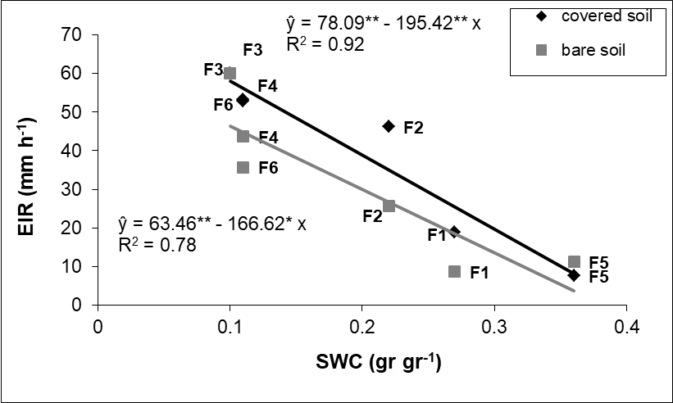

Figure 3. Relationship between soil water content (SWC) and equilibrium infiltration rate (EIR) for covered and bare soil. * and ** significant at, respectively, 5 and 1%, by the “t” test.

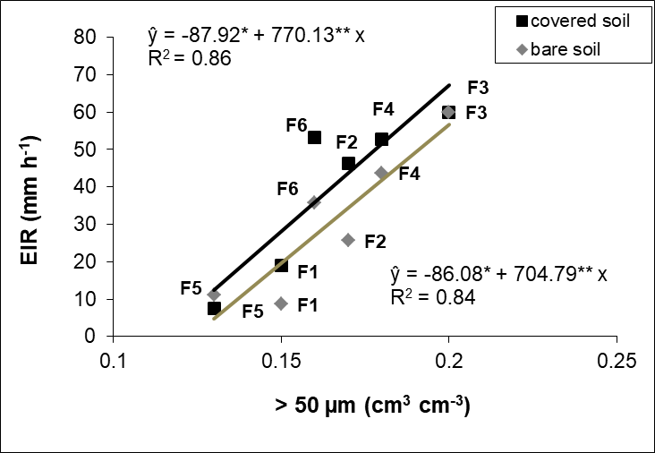

Figure 4. Relationship between volume occupied by macropores (> 50 µm) and equilibrium infiltration rate (EIR) for covered and bare soil. * and ** significant at, respectively, 5 and 1 %, by the “t” test.

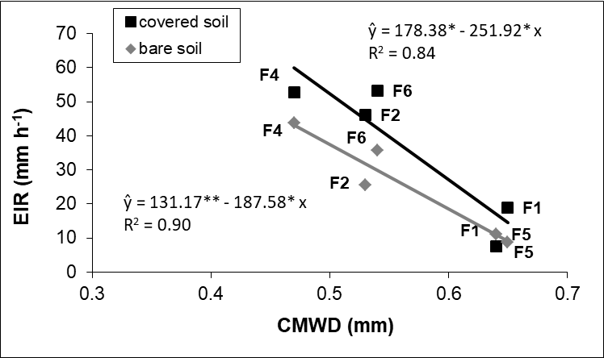

Figure 5. Relationship between the change in the mean weighted diameter of soil aggregates (CMWD) and equilibrium infiltration rate (EIR) for covered and bare soil. * and ** significant at, respectively, 5 and 1%, by the “t” test.

